ACMAD IT Department
Main Achievements - 2019-2022
Prepared by Mr ABANI AHMED Ali
- IT and Data Management Expert- Acting Chief Computing and Telecommunications Department-DIT (July 1st 2015-to date)
- Regional Advanced Retransmission Service- RARS Telecommunications Expert ACMAD /SAWIDRA-Project: (July2017-Sept 30th 2020)
- Head of Computing and Telecommunications Department at ACMAD (July 1st, 2007 - June 30^{th,} 2015)
- IT and Data Base Management Specialist ACMAD/ ISACIP project (July 2015-June 2016)
- IT Specialist ACMAD PDIPC /PKRESMIN Initiative (July 2016-June 2017)

,

Activities/Deliverable | Achievements | Constrains/opportunities/Comments
RARS-Africa network completion | 4 RARS station installed and are operational | RARS station maintenance and management.
RARS stations Installed and are operational | 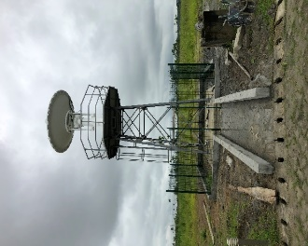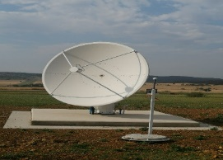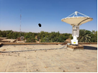  Niger RARS station  SANSA RARS station  Gabon RARS station  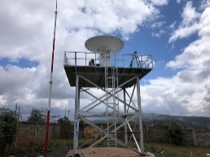  Kenya RARS station  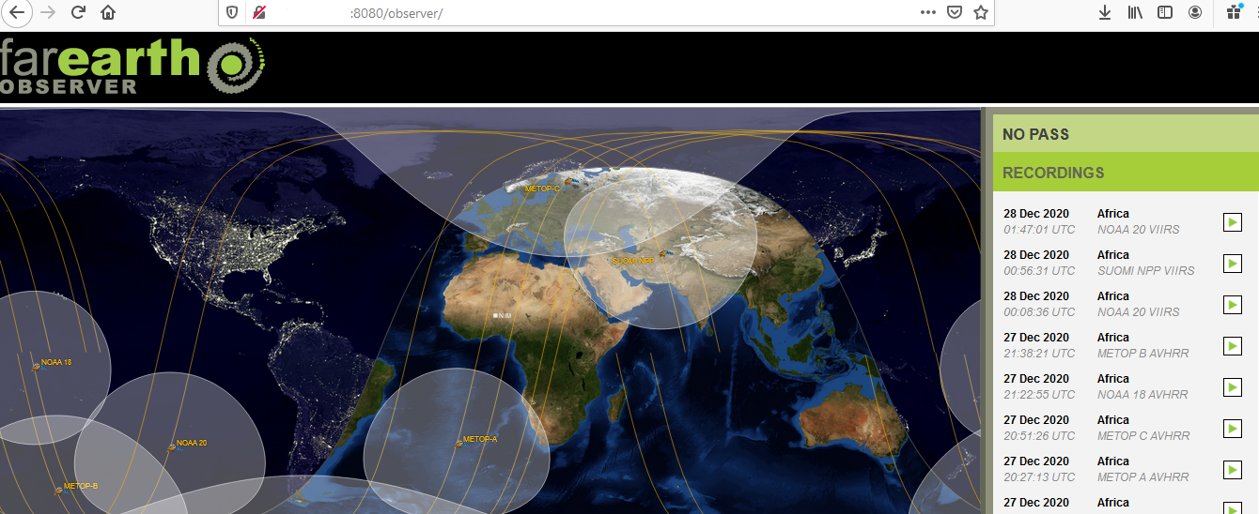  Farthearth RARS satation monitoring software running on Niger station. Nov 2021  SOLETOP maintenance report provided and accessible on the following link:  http://sgbd.acmad.org:8080/thredds/catalog/ACMAD/PROJECTS/SAWIDRA/RARS/SOLETOP_Maintenance_Hosting_sites_Tour/catalog.html | Despite the extensions of the SAWIDRA project, that ended on 30th September 2020, the activities continued under warranty period and commitments fulfillment of project’s partners. It is in 2021 that the upgrade of the D300 demodulator occurred and Pinkmatter updated remotely stations.  All 4 station have been installed and are operational. The Niger and Gabon station faced issues in September –October 2021 and this has been addressed under the ongoing warranty by SOLETOP. Niger is fully operational and Gabon maintenance is still on going. As part of RARS network monitoring, we have organized 10 RARS zoom coordination meetings with hosting sites and partners.
Data Management and High Performance Computing acquisition and installation  Climsoft Support | HPC installed at ACMAD and is operational  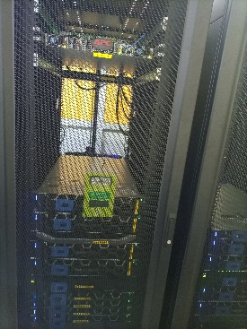  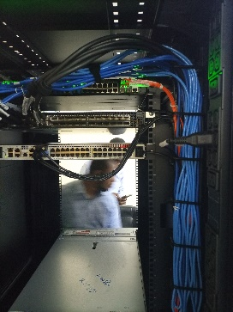  Servers for computing and services  - 2 x master DELL R740  - 2 x login DELL R740  - 4 x lustre DELL R740  - 4 x compute DELL R640  - 1 x monitoring DELL R640  Server CPU RAM Network Local Storage SAS cards to SAN  2 x Master 2 x Intel Xeon Gold 6134 3.2G (2 x 8 core) 192 GB 2 x 10Gb 2 x 1Gb 2 x InfiniBand 2 x 2TB HDD 2 x SAS (2 x 12Gbps)  2 x Login 2 x Intel Xeon Gold 6134 3.2G (2 x 8 core) 96 GB 2 x 10Gb 2 x 1Gb 2 x InfiniBand 2 x 2TB HDD  4 x Lustre 2 x Intel Xeon Gold 6136 3.2G (2 x 12 core) 384 GB 4 x 1Gb 1 x InfiniBand 2 x 2TB HDD 2 x SAS (2 x 12Gbps)  4 x Compute 2 x Intel Xeon Gold 6248 2.5G (2 x 20 core) 192 GB 4 x 1Gb 2 x InfiniBand 1 x 480GB SSD  1 x Monitoring 2 x Intel Xeon Gold 5118 2.3G (2 x 12 core) 96 GB 4 x 1Gb 1 x InfiniBand 2 x 480 GB SSD  13 servers 344 cores 3 TB 35 TB local storage 694 TB on SAN  Storage SAN  - 1 x DELL EMC PowerVault 4012  - 1 x DELL EMC PowerVault 4024  - 2 x DELL EMC PowerVault 4084  Climsoft vertion 4.1.12 has been installed at ACMAD by the consultant Mr Marcelin Habimana in june 2022. New features such as integration of data from paper archives have been integrated. The R-Instat feature as well has been integrated. | The HPC has been delivered and installed in 2021 by INTERTECH. The site acceptance test occurred on 2nd December 2021.  The Training occurred from 13th to 17th December 2021.  This activity is the last component of the SAWIDRA project which has been completed. The COVID-19 Pandemic situation has affected this programme.  The technical summary of ACMAD HPC is below:  Server: 13 servers,  CPU: 344 cores,  RAM: 3 TB;  Local Storage  SAS cards to SAN:  35 TB local storage  694 TB on SAN  After one year operation all the Licences expired and renewal estimated at about 40000 Euros. ACMAD decided to Stop the HPC and acquired reinstallation service in freeware’s mode estimated at 18 000 Euros. This process is on-going.  - Metadata management  - Status of data management in countries  - Climsoft Performance  - Climsoft installation procedures  - Climsof and R-instat set up  Full Expert’s mission report available at link below :  http://154.66.220.45:8080/thredds/fileServer/ACMAD/CTD/dataservice/Climsoft2022/Climsoft_R-Instat_Documentation/02062022Report_of_the_work_visit_to_ACMAD_Regional_Climate_Centre_Niamey_Niger_23-26_May_2022.pdf
IT System Administrator Support to ClimSA project | IT System administration and support provided | Below is the summary of main achievement of the IT support for all on going initiatives in ACMAD provided by IT department (DIT)
Upgrade of the PUMA2015 Station  Assistance to countries  IT support  IT and Website developed and updated | 3.1 PUMA2015 upgraded to version 1.3.5.  3.2 Country assisted technically for their optimal ICT activities.  3.3 IT support provided to all ongoing initiatives at ACMAD  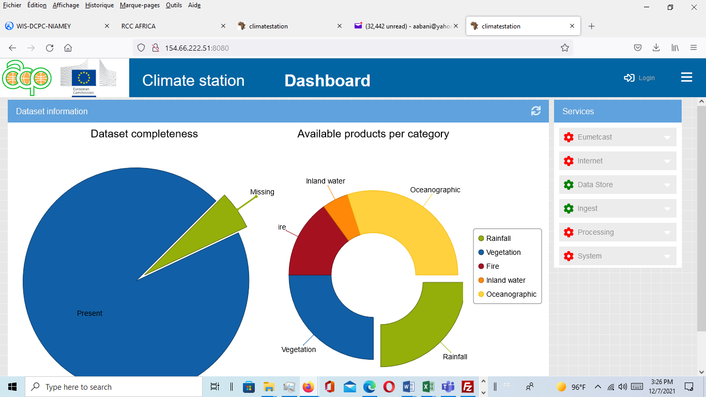  Climate Station main screen: Dashboard.  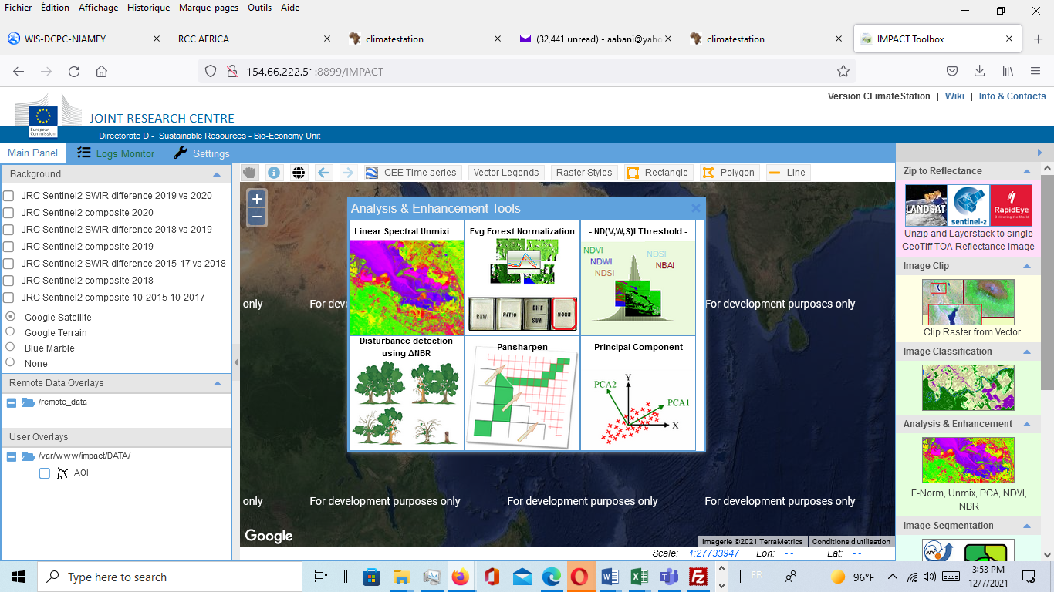  IMPAT5 Tool on Climate station at ACMAD.  Link to ACMAD’s climate station server:  http://climatestation.acmad.org:8080/  - ACMAD website developed and updated http://acmad.org | 3.1 PUMA2015 Station Upgrade.  In October 20121, The EUMETSAT OPS release the version1.3.5 of the PUMA2015 station. Which is about 8.9 GB software to be downloaded and install. We used and adequate Download manager and get the software. We created a bootable USB steak for the installation and we successfully installed the new version 1.3.5 Which is now available and operational at ACMAD. This has led to access to new category of data and products available in EUMETCAST broadcast.  As strategy we kept an addition PC4 with previous version for the access to old category of data.  This activity has been a significant input to ClimSA project and the DRR activities at ACMAD  3.2 Assistance to countries  In the framework of the support to countries we have provided technical support for the upgrade of the PUMA2015 of the Niger Met Service to version 1.3.5.  We have also given remote assistance to Madagascar in September 2021 for the PUMA2015 station whch was having challenges.  3.3 IT Support:  - In line with the on-going ClimSA project we have provided support for the specification verifications for the acquisition of new computing equipment to project staff. We have also provided technical support for the acquisition of 4 WIFI SMART BOXES with 100 GB data bandwidth each; to improve internet access at ACMAD.  - The ACMAD Climate station has been installed and successfully configure. This action incudes, the installation from scratch of the ML300 HP server with 48 cores on Linux Centos8. The Download and installation of the Climate station tool as well as the static Data from JRC website. The Docker has been installed and configure. We have configured the station with public IP to make it accessible remotely. In November JRC partner validated the installation. We installed the last tool which is IMPACT5 and the installation has been successful.  - IT support has also been provided to the CIMA/UNDRR initiative, we provided the necessary IT support the establishment of the Situation room at ACMAD. One of the latest support was the configuration to the ACMAD Network of the 3 consoles and one workstation to access Internet.  The ACMAD RCC web site has been updated as well as the SWIFT website with the development of all SWIF deliverable page on the New ACMAD site using WORDPRESS.  The support has been provided to displays new products and services from both Weather and Climate Departments. New pages have been developed such as cop26 page, SWICOF page and many development action to improve both RCC and ACMAD web site.  Routine update job has also been performed for the climate and weather bulletins update.
Capacity building | - Expert trainees, internship/fellowship supervised  - Internship staff Supervised, and Evaluated  - New plan and programme of Internship for IT staff prepared | - Suppervision of Mr Gema Katiellou on the IT support at ACMAD  - In August we welcomed a Student from Univesite of Maradi in Niger, miss Fadji mata K. and gave necessary support for training in IT.  - We also collaborated and give support to AIMS student, Mme ESTER O. remotely for the implementation of WIS at ACMAD. ACMAD-WIS action plan has been updated and share with her.
Meetings Workshops | - 10 RARS coordination zoom meeting organised with Hosting sites  - Participation to WMO DBNet coordination meeting  - Participation to WIS training organised by ASECNA  http://dcpc-niamey.asecna.org:8080/MessirWIS/srv/en/main.home# | - We have organized 7 RARS coordination meeting (reports in annex),  - We participated on line to the 5 WMO DBNet coordination meeting. we prepared an presented a ppt presentation on the RARS component of the SAWIDRA project.  - We attended the WIS ASECNA workshop from 05-  - We attended and contributed to DBnet-06 Meeting

