HIGHLIGHTS OF ACMAD’S ACHIEVEMENTS FOR 2019-2022

Standard operating procedures for forecasting developed with the SWIFT project test beds available for optimal operations. The African Continental Multi Hazards Advisory Centre is established and was inaugurated on October 31,2022.
https://www.undrr.org/news/heeding-call-early-warnings-all-african-multi-hazard-advisory-centre-established-niger
One of its products is available at: http://sgbd.acmad.org:8080/thredds/fileServer/FIT/BRIEFING/briefing.pdf

Four Regional Advanced Retransmission Systems (RARS) for Low earth orbiting satellite data, a High-Performance Computing system, a data server and a power generator to stabilize energy supply were procured and installed. ACMAD has organized on the job training, secondments, internships and fellowships for a minimum of twenty-two countries during the period with up to 15 experts attending per year.

Based on WMO competency framework for climate services and survey questionnaire responses, ACMAD undertook gap analysis on capacity for delivering climate information in southern Africa including an action plan to address the gaps. This plan is being implemented with development of training materials filling these gaps.
A new mechanism (ACCOF) to coordinate and harmonize methods, tools and climate outlooks products at continental level in collaboration with RCCs and NMHSs is operational since January 2022. 12 ACCOFs have so far been organized. During the 2021/22 cyclone season twinning exercises with NMHS, RSMC la Reunion, ACMAD and World Meteorological Centres demonstrated the operational cascading process delivering better advisories and warnings at national level. Products are available through ACMAD website at: https://acmad.org/

To support quality services, two synoptic/mesoscale forecast briefings per week, three sub seasonal forecast and one seasonal forecast discussions per month are organized with RCCs, RSMCs and NMHSs to provide inputs to the continental advisory centre. 2 annual state of climate reports for Africa were prepared and published with WMO. 12 ACCOFs statements were published. 7 RCOFs statements were published each year with ACMAD contribution on the continental perspectives and/or regional climate forecasts in regions with RCCs in development stage. The 4 mandatory functions of the continental RCC have been operational. Briefings/Debriefings for high impact weather and climate events opened to all NMHSs online have been opportunities for wider exchanges on new products. Case studies and debriefings post high impact events are included in preparatory activities leading to hazards situation reports generated by the continental advisory centre. 4 capacity gap studies available to guide RCC demonstration in ECCAS and ECOWAS as well as better use of ACMAD/RCC and ECCAS RCC products. 4 Continental User Interface Platforms ( https://acmad.org/index.php/workshop/ on Climate-DRR, Climate-water, Climate-agriculture and Climate-health to accelerate co-design, co-development of bespoke services. Moving operating procedures and integrating those into quality management system is a future effort.
Climate trends and impacts study report were prepared by ACMAD at the request of the UNECA Subregional Office for Africa as a contribution to the mainstreaming of climate information in the formulation the 2050 vision commissioned by ECOWAS. Such services for policy and planning are expected to be extended to other Regional Economic Communities supporting climate resilient and sustainable development planning.
ACMAD collaborated with the African climate policy centre for the review of the report on the impacts of climate change on Agriculture in pilot countries in Eastern, Southern and Western Africa. Strengthening of meteorological services for agriculture and extensions services was highlighted as a concluding priority policy in addition to investments in fertilisers and new crop varieties to address climate change adaptation and support mitigation efforts. The two initiatives with UNECA demonstrated operational collaborations to be strengthened for sustainable development planning well informed by climate knowledge in Africa.

The PUMA station is operational and support to NMHSs for maintenance have been provided upon request. The climate station continued to be tested in collaboration with EU JRC under ClimSA project. Data rescue for Africa made progress with images generated from microfiches by Copernicus programme.
More than 10 trainings including sessions for research on predictability are organized each year as part of ACCOFs, RCOFs, on the job training, secondments and workshops covering African NMHSs and RCCs.

More than 10 countries were exposed to training and forecast verification research each year. New products, methods and tools updates, training materials, procedures and instruction manuals are deliverables of research projects.
New products for meningitis surveillance and control is available https://www.sciencedirect.com/science/article/pii/S2405880722000449 .

Predictability research on the potential for improving use of dynamical model forecasts in the regional climate outlook forums, to improve the reliability of seasonal forecasts in the regions and the objectivity of the seasonal forecasting process used in the PRESASS regional climate outlook forum generated findings published in the American Meteorological Society’s weather and forecasting journal. The paper is available at https://doi.org/10.1175/WAF-D-19-0168.1.

Standard operating procedures for nowcasting and forecasting developed and piloted in SWIFT operationalized at ACMAD. An example of procedure is available at https://eprints.whiterose.ac.uk/185379/1/SWIFT_nowcasting_operating_procedure.pdf .

Innovations on tools delivered U-CLIP and CLIMTAG platform, SAF Nowcasting, MYDEWETRA for city resilience and adaptation to climate change, agriculture calendar updates, early warnings. Future efforts high resolution NWP for impact based forecasting is planned.

The 4th session of AMCOMET declaration in Cairo called for ACMAD to become the technical arm of AUC on climate matters. A briefing was organized for the AU Permanent Representative Committee of Ambassadors’ Sub-Committee on environment to raise awareness on ACMAD mission, vision and main achievements supporting understanding of the centre’s role as technical arm of AUC on climate matters. Contacts maintained with UNECA with a draft relationship agreement between ACMAD and AUC implementing the AMCOMET Cairo Declaration submitted to UNECA legal office. A letter from the ACMAD Board Chairperson was sent to UNECA executive Secretary to request for a meeting on the improvements needed on the governance of ACMAD and the implementation of the relevant provisions in the Cairo declaration.
The formulation of the ACMAD 2020-2023 strategic plan and related operating plan was completed after review by the Scientific Advisory Committee and approval by the board. 7 financial reports and external audits were carried out covering years from 2015 to 2021.
Administrative, financial and accounting procedure manual completed and organogram revised. The last 3 years of audited accounting and financial reports are available in IFRS format. Future effort would be to consider EU pillar assessment to progressively become a partner of the EU for implementing its external actions. As an EU partner for implementation, the centre is expected to mobilize the substantial investments required for NMHSs modernization programmes. Regular progress or annual reports and projects audits have been provided to relevant bodies and donors.
197 staffs were mobilized with support of partners to implement activities and projects. Future efforts to raise the countries contributions reducing heavy reliance on project staff is expected with the formulation of the 2024-27 strategy and related four years’ operating plan. These documents would support resource mobilization with presentations at high level events.
MOUs and agreements facilitated formulation and implementation of projects. Main projects at the Centre includes ClimSA, FOCUS-Africa, SWIFT, GSTIC, UCLIP, KIMPALA, MUKAU, AMHWEAS, CVM3. Key organizations operate partnerships and consortia for implementation of these project including the African Union Commission, the World Meteorological Organization, The African Development Bank, Climate Vulnerable Forum with the V20 group of states, The global centre on adaptation, the University of Leeds, the Belgium and Flemish government through VITO Institute, the Joint Research Centre of the EU, EUMETSAT, the African institute for Mathematical Studies, the UN Economic Commission for Africa, the UNOCHA, the IFRC.

To further develop partnerships, meetings, dialogue days and visits during the period involved high level officials including:
- His excellency M. Minister of state for foreign affairs and cooperation of Niger
-The Belgium development cooperation Minister https://www.wehubit.be/en/node/260
- The UK ambassador in Niger
-The Italian ambassador in Niger
- The Belgium ambassador in Niger
- The US Department of State

During Conferences of Parties to the UN Framework Convention on Climate Change, meetings and events were organized to strengthen and further expansion of partnerships.

The EU green deal adaptation strategy, the President Biden’s emergency plan for resilience and adaptation, The Climate Vulnerability Monitor of the Climate Vulnerable Forum, The METEOSAT Third Generation and African Meteorological Satellite Applications Facility, the African multi–Hazards Early warning and Early Action System are key frameworks and programmes supporting future activities.

---------------------------------------------------------------------------------------------------
Key web references are provided in the table below.

Projects | Web links
ClimSA | https://acmad.org/index.php/climsa-activities/
FOCUS Africa | https://focus-africaproject.eu/context/
SWIFT | https://eprints.whiterose.ac.uk/174093/
UCLIP | https://www.wehubit.be/en/node/97  https://vito.be/nl/urban-climate-information-platform-niger-u-clip
CVM3 | https://www.v-20.org/climate-vulnerability-monitor%3A-climate-change-causes-loss-and-damage%2C-unequally-impacts-vulnerable-nations-and-indiscriminately-creates-global-crises
MUKAU | https://edo.jrc.ec.europa.eu/gdo/php/index.php?id=1004
GSTIC | https://www.climate-action-programme.be/project/increasing-urban-tree-density/
KIMPALA/CLIMTAG | https://climtag.vito.be/en  https://climtag.vito.be/en/expertise/agro-sector
AMHEWAS | https://www.undrr.org/news/heeding-call-early-warnings-all-african-multi-hazard-advisory-centre-established-niger
SAWIDRA | https://www.preventionweb.net/news/african-development-bank-supports-development-satellite-observations-african-early-warning
With the fast-moving extreme temperatures and heavy precipitation, losses and damages due to extreme events is threatening different facets of the African economy and society. Operationalizing Multi-hazards early warning system in Africa and the COP 27 landmark agreement on losses and damages are key priorities.
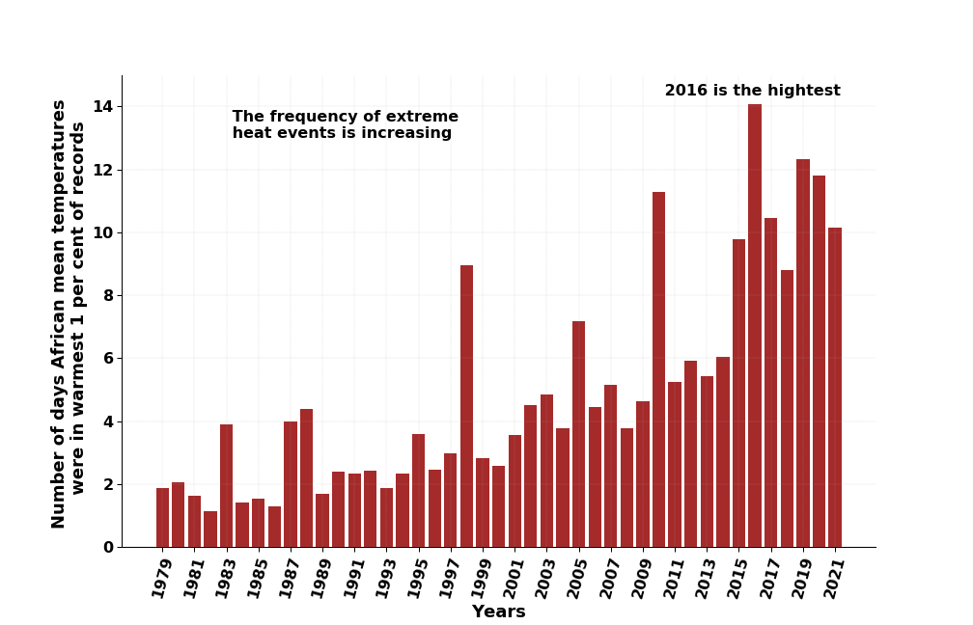
Figure 1: Number of days per year with extreme mean temperature in Africa. 5 times increase on the number of days with extreme temperature over a 40 years period from the 80s to the 2010s.
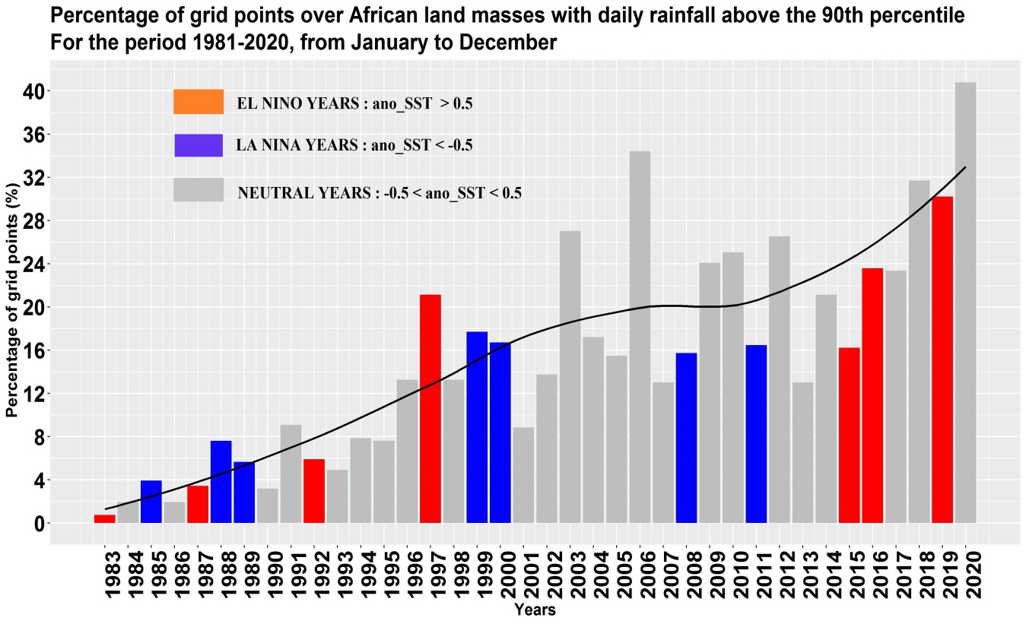
Figure 2: Percentage of African land surface hit by heavy precipitation. 4 times increase of this rate over a 40 years period from the 80s to the 2010s. With less than 10% of the African land surface was hit by heavy precipitation potentially leading to floods in the 80s. this indicator reached 40% in 2020 with up to 2% of population in some African countries affected by floods.

