Intra ACP GFCS Grant/ Intra-ACP Climate Services and Related Applications (ClimSA) Programme: Support to African Centre of Meteorological Applications for Development (ACMAD)

SECOND ACMAD CONTINENTAL STEERING COMMITTEE (ACSC2)
OF THE ClimSA ACTION

DOCUMENT N° ACMAD/ClimSA/ACSC2/DOC2.2
REPORT FOR YEAR 1
Period: March 2021-March 2022

INTRODUCTION
This document is the first annual report of the ACMAD/ClimSA project. It covers the period from March 2021 to March 2022.
The ClimSA project at ACMAD started with inception period with recruitment of ACMAD/ClimSA team, mobilization of partners through the kick off event and review of the log frame. The main implementation period started after about 3 months of inception period.

This report monitors the ACMAD/ClimSA log frame indicators of the five outputs. It provides an overview of deliverables and milestones. After highlighting the status of indicators, the report examines key facts, meetings and events that occurred during the year.
The year 2 work plan, lessons learnt from one year of implementation, the update list of ACMAD/ClimSA project staff and summary expenditure report are provided as annexes.

- EXECUTIVE SUMMARY

To foster sustainable development at the recent Eight Africa Regional platform for Disaster Risk Reduction and seventh High Level Meeting for Disaster Risk Reduction from 16 to 19 November 2021, ACMAD through ClimSA supported climate information provision contributed to raise awareness on climate hazards, trends , extremes and impacts as well as current predictability of related meteorological processes and phenomena in Africa. Therefore, ACMAD/ClimSA supported climate science informed declaration adopted by Ministers and Head of Delegations in the Nairobi declaration on accelerating achievement of the Sendai Framework for Disaster Risk Reduction in Africa.

Muti-Hazards Early Warning System is being implemented with ACMAD and partners. A Continental Mult-ihazard Advisory Centre is established at ACMAD providing continental advisories and watches as a prototype service to support the continental disaster risk management community active in emergency operations centres, situation rooms and emergency management and humanitarian action.

Climate anomalies, climate hazards, potential impacts, response decisions and measures are prepared and published as brief statements for DRR policy and decision makers. An example of such a brief statement was delivered in late August for the September to December 2021 season in Africa. It highlighted expectation for the current drought in East Africa, its potential impacts and proposed response measures. A first of its kind policy response in the form of a declaration of drought emergency by the Kenya Head of State in September 2021 was reported by the Kenyan finance minister at the COP 26 climate finance day. He recognized the benefits related to early warning and early declaration of state of drought emergency including government, humanitarian and other DRR actors’ interventions ahead of the events reducing negative drought impacts.

To strengthen the climate service value chain, a Continental Multihazard Advisory Centre is established at ACMAD providing continental advisories and watches as a prototype service to support the continental disaster risk management community active in emergency operations centres, situation rooms and emergency management and humanitarian action. During the 2021/22 cyclone season, the centre provided advisories up to 5 days ahead of strong storms and cyclones, vigilance up to 3 days ahead and supported NMHSs in the preparation and delivery of warnings ( e.g Meteorological services of Madagascar).

As part of user interface strengthening (output 1), Stronger interactions with Disaster management systems at continental and regional levels were supported.
To continue operations for quality services (output 2), the continental Regional Climate Centre continued its operations with new products on cyclones, mesoscale convective systems tracking, heavy rains advisories, watches/vigilance. New services for the agriculture calendar, health, past climate analyses, current climate monitoring and future climate scenarios have been developed and are being tested.
Access to data (output 3) is seeing improvements with installation of climate station, maintenance of PUMA station, download of open WIS node application, installation of DCPC Niamey with ASECNA, database management with Climsoft and THREDDS is maintained and operational.
Capacity building (output4) is a key enabler for climate services delivery. Training on the Job, secondments of staff from NMHSs and other partners, internships were organized for up to 10 countries. Technical support to prepare criteria for selection of countries and master students on climate Services was provided to ECCAS and AUC. Training workshops and for a were organized or attended.
To mainstream climate information in planning and policy making (output 5), ACMAD attended relevant for a at continental, ACP and global levels
Specific focus interventions with advisories and outlooks have been provided to disaster management communities. A first recognition at ministerial level at cop 26 climate finance session of drought emergency declaration well ahead of the drought currently affecting IGAD region. Tools for climate mainstreaming is being transfer trough training and technical assistance with ClimSA Technical assistance Team and University partner in the USA.

- Monitoring based on Log frame Indicators

2.1 Impacts indicators

To foster sustainable development trough decisions and actions to adapt to climate change, ACMAD supported the continental platform and African working group for DRR with policy briefs highlighting climate hazards for the upcoming season facilitating future hazard identification, potential impacts estimation and preparation and response measures proposed for action or update of emergency plans.

Engagement on agriculture policy with Continental humanitarian networks coordinated by AUC/DREA emphasizing agriculture commodity and particularly food reserve to reduce inflation in drought years which have become quite frequent across Africa. Therefore, the indicator is completed at 50%. It is expected that services from the situation room set up at ACMAD, AUC and ICPAC when operational will contribute to resilience at continental, regional, national and community levels.

ACMAD through Regional Climate Outlook Fora provides climate statements and advice to humanitarian sector trough the consultative group for disaster management in West Africa coordinated UN OCHA and covering ECOWAS and ECCAS. Disaster management and civil protection directorates benefit from presentations and inputs for emergency planning ahead of the rainy season.
Engagement and outreach with other RECs through RCCs, developing RCCs and OCHA are to be pursued.

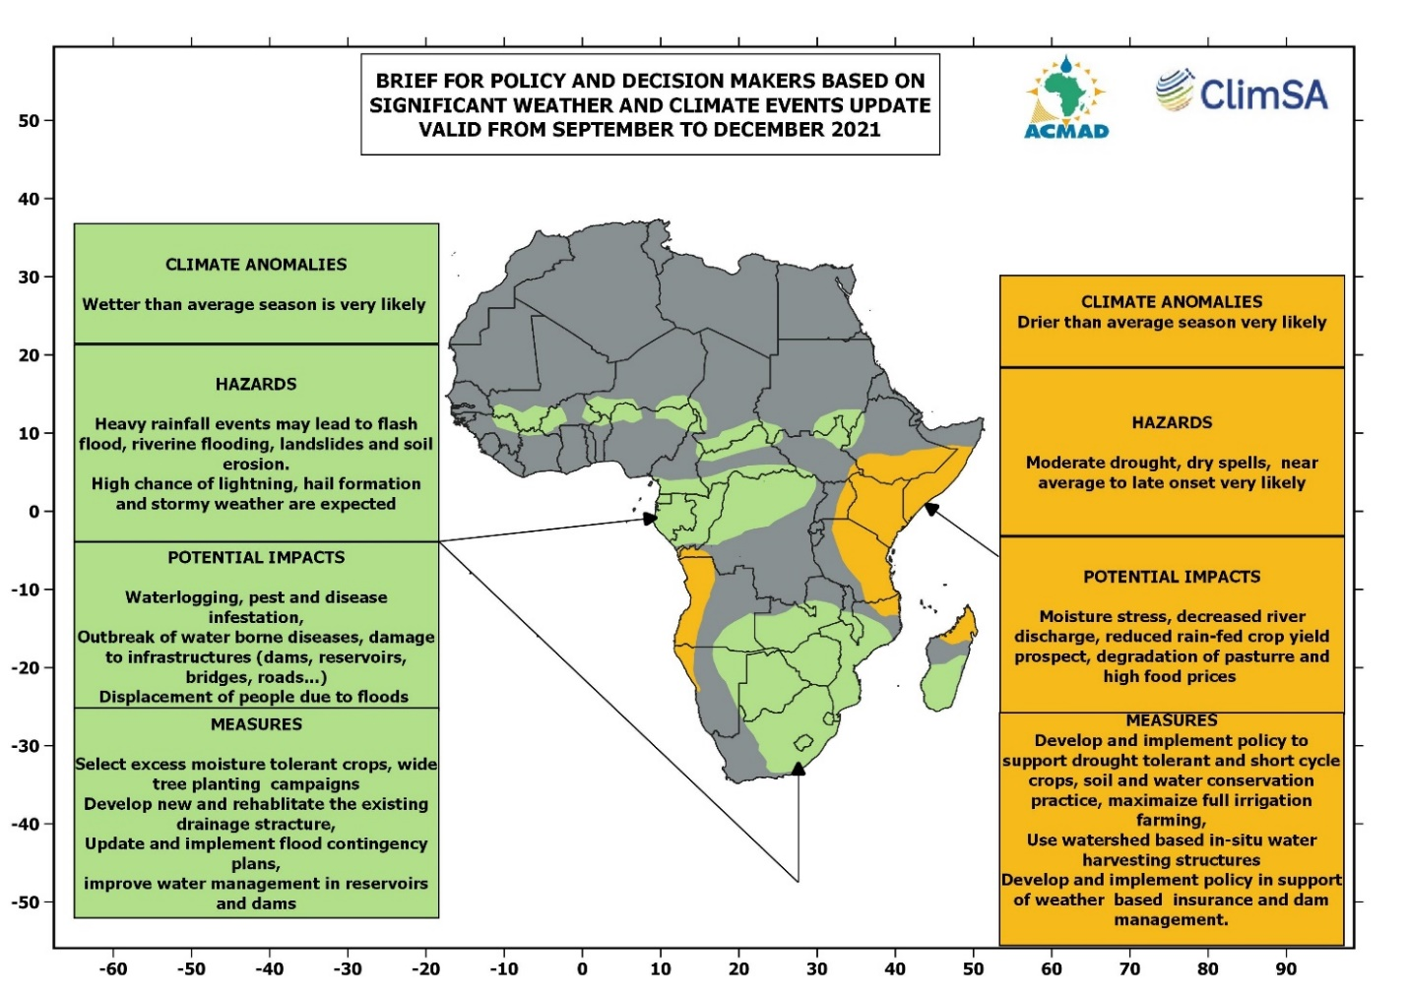

Figure 1: Brief for policy and Decision makers highlighting drought in East Africa, potential impacts and response measures published in late August 2021 and valid for September -December 2021 season. Drought over eastern Africa and northern Madagascar highlighted. The minister of finance from Kenya recognized the advisories and indicated that emergency declaration on the 2021 drought in Kenya was activated earlier. In recent past years, emergency status has been declared in February of the year following a October-December drought.

2.2 Outcomes indicators

The African Union Commission Department for Agriculture Rural Development, Blue Economy, and Sustainable Environment (AUC-DARBE) and related divisions of Agriculture, environment, Disaster Risk Reduction are benefiting from the annual state of climate for Africa, statements and briefs on the seasonal climate outlooks advising African negotiators during side events at COP 26, providing advisories trough continental climate watch to the situation room at AUC in demonstration mode ( figure 1).

The UNECA Division in charge of technology, climate change and natural resources is contributing to and benefiting from the annual state of Africa’s climate report to support preparatory workshop for African stakeholders ahead of UNFCCC COPs. Side events at the Africa Pavilion at COP 26 were organized

Benefits for RECs include recommendation made at continental steering, advisory and technical coordination meetings/sessions to support planning for the RCC demonstration phases for climate Centers in ECCAS, ECOWAS and SADC CSC regions.

ACMAD participated at events organized at the Africa Regional Platform for DRR attended by AWGDRR members. ACMAD organized side events at COP 26 attended by members of AGN.

A Continental Mult-ihazard Advisory Centre is established at ACMAD providing continental advisories and watches as a prototype service to support the continental disaster risk management community active in emergency operations centres, situation rooms and emergency management and humanitarian action. Technical assistance and capacity building with information services is therefore provided.

To strengthen climate services value chain, three AUC departments have been reached ( DREA, Social affairs, Peace and Security). 3 of the targeted 4 departments (75% completed).

Meetings and dialogue with AWGDRR, Pan African Farmers Federation, and Clim Health Africa as well as other Health networks in Africa are planned during the second year of implementation. Out of the 20 meetings or events planned, 2 have been organized (10%) under AUC coordination with the AWGDRR in early 2021 and side events on the state of climate for Africa in 2020 for African Negotiators by ACMAD at COP 26 in Glasgow.

ACMAD started interactions with WMO and developing RCCs in the Southwest Indian Ocean with SWIOCOF and RCC demonstration scoping and planning meeting with ACMAD expected to provide capacity building and technical assistance during the demonstration phase. Planning work has started with questionnaire design for a survey to identify gaps and develop implementation plan for ECOWAS and ECCAS RCC demonstration. Given the expected sequence of events to build the demonstration plan, implement the plan providing capacity building and technical assistance for the demonstration, initiatives have started with tools for data collection to prepare plans.

2.3 Outputs indicators

At the user interface (output 1), one (DRR interface) among the expected 3 user interfaces has been strengthened with situation rooms at continental and regional levels in IGAD (33.33% target reached).

The consultative group on disaster management in West Africa coordinated by OCHA including ECCAS is an operational interface supported by ACMAD products and services tailored for these regions for disaster management planning. One out of five targeted UIPs that is 20% is operational.

Under output 2, infrastructure, methods, tools and continental products and mechanisms (e.g. ACOFs) are initiated to operationalize the continental climate service information system. Institutional capacity with stronger partnership with global centers is operational. The mandatory and some recommended functions (Research and innovation, related data management…) are delivering. Stronger interactions with RCCs of other ACP regions to further support CSIS are planned for the coming years. Among the three sequences of activities, internal capacity development at ACMAD (25%), building partnerships with Global Centers (25%), NMHSs (25%) and other RCCs (25%) of ACP region, internal capacity is reached (25% of the target completed).

Climate stations are installed a pilot RCCs for demonstrations as a first step toward operationalization. One out of the three steps (installation, test, operationalize) for operationalization is completed (33%).

No station is delivered and operational yet at regional level.

New climate service for Agriculture (start, end of the agriculture season, disruptions on rain distribution during the season) is being finalized supporting regular and necessary updates on agriculture calendar across Africa. Advisories and watches during the cyclone season highlighting expected cyclone tracks, heavy rains, strong winds and potential impacts are available. Outlooks up to week 2 ahead are available and have completed the portfolio of services from a few days to a season ahead. The major challenge is the completion of an operation delivery chain, effective support to countries for warnings through the situation room set up, effective communication leading to early action. New products for agriculture and DRR are developed, testing and operationalization are remaining (33% completed).

Under output 3 on access to data, Agreement for data with EUMETSAT was revised and signed. One of the 2 expected agreements done (50%)

Access to ACMAD products by SADC CSC and IOC developing RCCs as well as NMHSs has been improved with the organization of monthly ACCOFs. 33% completed with more effort needed to develop access to data through WIS DCPC and NCs as well as Climate Stations combining EUMETCAST and internet including WIS.

Under output 4, to improve RCC staff competencies ACMAD organized training sessions online at GHACOF, SARCOF, SWIOCOF, PRESASS; PRESAGG and ACCOF. 10 Countries benefited from combined on the job training, secondments, internships and fellowships. More than the 4 trainings planned per year were organized ( 25% completed after one of the 4 years).

4 ACMAD staff trained in year 1, one staff for each of the following centres AGRHYMET, ICPAC, SADC-CSC, IOC RCC, ECCAS RCC, UMA RCC. 10 staff for year 1 reached with only one woman. 33 % of total expectations for 4 years completed in year 1. The gender indication is 1 completed with a target of 5 in year 1. Only one completed for the expected 20 women in 4 years (5%).

Four internships supervised with two women for 6 months internships. 25% of the expected total of 16 interns or on the job trainees/seconded experts is completed including 2 out of the expected 8 women in 4 years (25% women after year 1)

Two publications are expected in 4 years with the first on year 2 or 3 and the second in year 4. Developments on seasonal sub seasonal forecasting, medium range forecasts and climate projections are expected to deliver these publications.

Two fora with providers and users are to be organized at continental level. One in year 2 or 3 and the second in year 4.

Under output 5 on mainstreaming climate services and enhancing sectors policies, decisions up to 30 communication materials on success stories of climate inform policies and decisions ( videos, flyers, brochures and stories…). Speeches of high level officials at AWGDRR and platform, Agriculture fora, water and Health fora and conferences are being collected to be analyzed.

Three workshops with users on climate services in planning and policy disaggregated per sector, gender and sub regions are planned. A first workshop is expected in year 2.

2 support tools for climate resilient policy/decision making developed or configured. ACMAD staff is being trained through ClimSA TAT online at University in the USA. The tools are expected to be installed, configured, and used for training during upcoming years.

Two impact assessment reports prepared with products from the tools in years 3 and 4.

At least 3 institutions or government representatives recognizing at least two examples of having used climate information developed within the action. Counting expected to start in year 3.

- Major Meetings and events

The participation to COP 26 in Glasgow with 3 side vents on the use of Satellite data and products for disaster resilience in Africa, highlights in the state of climate for Africa, climate trends and impacts as part of the UNFCCC subsidiary body od Science and Technology meeting (SABSTA).

ACMAD ClimSA chaired session and made presentations at the EUMETSAT User forum for Africa. ACMAD ClimSA provided continental climate outlooks and introduction to indicators of the agriculture calendar and required climate products for their generation at GHACOF, SARCOF, SWIOCOF, PRESASS, PRESAGG.

ACMAD organized monthly Continental Climate Outlooks and related user events. The AMCOMET session was an opportunity for the highest ministerial authority to focus attention on early warning systems development in Africa.

The table below provides a list of events during year 1.

 | Meeting/Forums/Workshop/Conference | Date | Venue
1. | PRESAGG | 22 – 26 Feb 2021 | Online
2. | PRESASS | 26 – 30 May 2021 | Online
3. | PRESASS DRR-ECOWA Humanitarian | 04 May 2021 | Online
4. | GHACOF | 26 Aug 2021 | Online
5. | SARCOF | 30 – 31 Aug 2021 | Online
6. | PRESAC | 27Sept – 01 Oct 2021 | Douala – Cameroun
7. | MEDECOF | 21 – 25 May 2021 | Online
8. | EPR WG ECOWAS/ECCAS | 23 March 2021 | Online
9. | KICK OFF CLIMSA | 15 April 2021 | Online
10. | ClimSA Steering Committee | 29-30 June 2021 | Online
11. | GECEAO | 01 - 02 Jul 2021 | Niamey – Niger
13. | AMCOMET | 16 – 17 March 2021 | Online
14. | SWIOCOF | 23 Sept 2021 | Online
15. | WMO RAI Session | 25 – 26 Jan 2021 | Online
16. | CLIMSA Forum | 15 – 16 18 Nov 2021 | Online
17. | EUMETSAT user Forum Africa | 6 – 7 Oct 2021 | Online
18. | COP26 | 01 – 12 Nov 2021 | Glasgow – UK
19. | MHEW/EA Conference | 20 – 22 Oct 2021 | Hybrid (Online – Nairobi - Kenya)
20. | Africa DRR Platform Forum | 19 Nov 2021 | Online
21. | ClimSA – ECCAS Steering Committee | 23 – 24 Sept 2021 | Douala – Cameroun
22. | ClimSA-AUC Steering Committee | Dec 2021 | Hybrid (Online – Gaborone- Botswana)

LIST OF ANNEXES

Annex I: List of ACMAD/ClimSA project staff as of March 2022

AnnexII: Summary Expenditure Report

Annex II: Work plan and budget for year 2 (separate document)

