9th Extraordinary Session of the ACMAD Board of Governors
Location: online
Dates: January 10-11, 2023

DOCUMENT N° ACMAD/BoGExt9/DOC 5

The African Multi Hazard Early Warning and Action System in support of the early warning for all initiative: The role of Meteorological and Hydrological services and other stakehokders

December 2022

Action required

The Board is invited to discuss the role of continental, regional and national meteorological and hydrological centers and stakeholders for the early warning for all initiative in Africa. It is invited to provide advise in the roles along the warning value cycke.

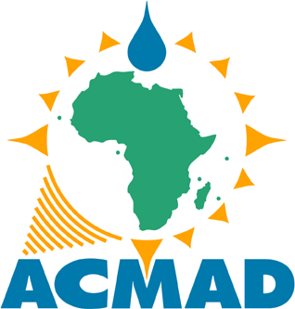

ACMAD Vision 2030

An African continent where all nations are benefiting from a world class operational continental meteorological centre to become resilient to extremes events and empowered to support their sustainable development with better meteorological services

Given the impacts of extreme events in Africa and the urgent need for action, operationalization of the Africa Multihazards Early warning and action system spearheaded by the African Union Commission and partners is a priority response measure. This document summarizes multisectoral impacts of disasters in Africa and describes the institutional structure and cascading processes from global to continental, regional and national lto support the early warning for all initiative in Africa.

1 BACKGROUND

- It is well recognized that Multi Hazards Early Warning and Early Action Systems are essential for people to prepare and act early in case of disasters. Governments and partners have demonstrated evidence that Early warning systems well implemented support substantial reduction in disaster losses.

- The Programme of Action for implementation of the Sendai Framework for DRR in Africa, the revised African strategy on meteorology target by 2030 to develop and modernize early warning systems generating information accessible and available on hazards, impacts, disaster risk assessments, preparation, emergency, response measures and plans.

- The African Centre of Meteorological Applications for Development (ACMAD), the African Union Commission, the World Meteorological Organization, the UNDRR, the International Centre for Environmental Monitoring (CIMA-Italy) and other partners are strengthening capacity in Africa to deliver multi-hazards Early warning information for climate change adaptation and Disaster Risk Reduction.

- Some African countries have started work to establish standard monitoring and warning systems. Integration from local, national, regional and continental levels and operational linkages with preparation, emergency response and action planners, sustainable financing mechanisms ensures that the right decision makers and emergency or humanitarian actors are reached at the right time.

- A continental Multi Hazard Advisory Centre is established at ACMAD to support the situation room based at AUC in Addis ABABA with regular continental hazards watches and disaster situation reports generated derived from interpretation and use of Numerical Weather prediction and other products. The situation room uses situation reports, watches and advisories for awareness raising on hazards and risk, communication and discussions towards planning and update of contingency or emergency actions.

- This paper summarizes current hazards and related significant impacts in Africa. It discusses the Meteorological and Hydrological Services and stakeholders’ roles to better operate the Early warning systems in Africa reducing disaster damages and losses which have become significant reaching up to 2% of gross domestic product growth rate in some countries. This rate reduction is equivalent to about 50% of current GDP growth rates for some African growing economies. Reducing steep and rising cost associated with weather extreme is a key outcome from early warning implementation. A strong and integrated African economy expected from the African Continental Free Trade Area will be possible through building resilient communities across the continent.

2. IMPACTS OF DISASTERS IN AFRICA

Recent floods in Kinshasa (DRC) in December 2022, was another wake-up call with significant damages and loss of life. It was a clear test of how effective are early warning systems . Extremes weather are becoming part of our daily lives.
The state of climate report for Africa in 2021 highlighted the following key messages on hazards and impacts:
- In Africa, the rate of implementation of Multi-Hazard Early Warning System (MHEWS) is lower than in other regions, with only 4 out of 10 people covered. There is need to fill the capacity gap in collecting data for basic hydrometeorological variables which underpin better climate services and early warning systems to save lives and livelihoods. There should be greater investment in end-to-end drought and flood early warning systems in at-risk LDCs, especially for drought warning in Africa.
- Floods and droughts, sea level rise, and extreme weather events all influence displacement patterns within borders and across international borders. In 2021, around 14.1 million people were internally displaced in Sub-Saharan Africa, including around 11.5 million due to conflict and violence and 2.5 million due to disasters.
- Currently, 28 countries provide climate services from basic to essential level and only 9 provide those services at a full level. Only four countries are providing end-to-end drought forecasting or warning services at a full/advanced capacity level.
- Around 418 million people still lack even a basic level of drinking water and 779 million people lack basic sanitation services
- 27 out of 51 African countries for which data are available have inadequate capacity to implement Integrated Water Resource Management.
- A global warming of 1.5 °C is projected to be accompanied by a decline of 9% of the maize yield in West Africa and 20%-60% of the wheat yield in southern and northern Africa.
- In West Africa, the long-term decline in river flow is attributed to increase in temperature, drought, and increased water demand.
- Many parts of Northern Africa experienced extreme heat, especially in Tunisia, Algeria, Morocco and Libya. This was accompanied by wildfires. Sand and dust storms were a recurring problem.
- Drought in East Africa has worsened following consecutive failed rainy seasons combined with heightened conflict, related population displacement, and COVID-19 restrictions. High food prices impeded food availability and access, leaving more than 58 million people in conditions of acute food insecurity.
Strengthening early warning systems is a major recommendation to address the challenges and impacts presented above.

3. REMARKS ON THE ROLES OF CONTINENTAL, REGIONAL AND NATIONAL
INSTITUTIONS
To reduce the impacts presented in the previous section, under the leadership of the African Union Commission (AUC), a continental multi hazards early warning and action system is under implementation. The multi hazards advisory centre is part of the institutional framework to operate the system.

Recognizing that impacts are felt from local to regional and in some cases continental and global levels, the Early warning system should operate at all these scales.
Based on the WMO led cascading principle demonstrated with Severe Weather Forecasting Demonstration Projects.

The National Meteorological and Hydrological Services work at country level on forecasting, warning and information dissemination on dangerous conditions. NMHSs will organize national level briefings and debriefings with participation of the National Framework for Disaster risk reduction stakeholders.

Given the regional, continental or global impacts that may arise, regional and sub-regional centres will work to deliver outlooks, advisories and watches supporting warnings at national level. They will organize briefings and debriefings to prepare, facilitate understanding and use of information.

Their assistance for national capacity building and transfer of technology on observations, weather, hazards and impacts forecasting and warning as well as effective risk and response measures communication and is essential. Sensors and observing networks management technologies, atmospheric, environmental and socio-economic modelling technologies, communication and behavioural science and technology are required areas of strong stakeholders’ involvement to build capacity, complementarity and subsidiarity.

The RSMCs with sub-regional mandates will contribute with watches 1 to 2 days ahead and inputs to briefings and debriefings from their sub-regions. RSMCs also liaise with other sub-regional organizations active in impacted sectors as well as the Regional Framework for Disasters Risk Reduction under the Regional Economic Communities (RECs).
The Continental Centre will coordinate briefings and debriefings, contribute to situation and continental outlooks and advisory reports for the situation room established at the AUC headquarters in ADDIS ABABA, harmonize methods, tools and products. Advisories are provided up to 5 days ahead of severe events.
Situation assessment report, outlooks, advisories, watches and warnings delivery and use affect the implementation of the mandate of organizations and coordination along the warning value cycle between AUC, RECs and member states for effective action is to be structured.
At continental level, the advisory centre working with global, regional and national data and products consolidate continental products disseminated to the continental User interface Platform on Climate and DRR for impact forecasting and response planning and action, communicated through the African working group for Disaster Risk Reduction and other continental scale humanitarian and disaster management bodies.
At regional level, Regional Specialized Meteorological Centres and/or Regional Climate Centres and partners with mandate covering RECs provide products. These products include regional weather, hazards and impact forecasts, watches, contribution to situation reports and risk profiles. This information is harmonized with national and global levels, consolidated at continental level to raise awareness on risk and mobilize stakeholders towards the countries or regions most at risk. At national level downscaling and communication through the National platforms for disaster risk Reduction is essential for local Action.
At national level, National Meteorological and Climate Centres provide in collaboration with National Disaster Management and/or Civil Protection Agencies authoritative warnings discussed in the national user interface platform for climate and DRR and disseminated through the national platform for DRR including humanitarian agencies country offices. National level products include local risk profiles and situation reports, national public alerts, vulnerability and risk assessment reports, public awareness and risk communication materials, national contingency and emergency preparation simulation exercises reports, National disaster and statistics database and information system.
The ultimate goal being to reduce disaster damages and losses, weather, hazards and impact forecasts are generated to support warning.
Numerical weather Prediction and nowcasting tools are the foundational tools for weather and hazards forecasting. Continental and regional Centres are to provide technical assistance to countries to operate these tools.
Translation of hazards forecasts into impact forecasts is interdisciplinary with forecast providers and DRR/humanitarian actors. It is at the core of effective warning and is expected to be the role of the Climate and DRR User interface platforms. Support of Continental and regional (forecast providers and impact sectors users) centres using advanced methods, tools and products for forecasting weather, hazards and impacts is expected to strengthen national warning efforts.
To raise awareness of the risk, communication is pivotal and requires a strategy and implementation plan. WMO provides guidelines and technical assistance is expected from continental and regional centres and political bodies with operating instructions manual and pilot demonstrations at country level. Good practices in communication between national, regional, continental and global stakeholders are to be identified and demonstrated.
Based on knowledge and understanding of the warning, decisions and actions are defined, harmonized and implemented by stakeholders of the DRR platforms to reduce losses and damages.

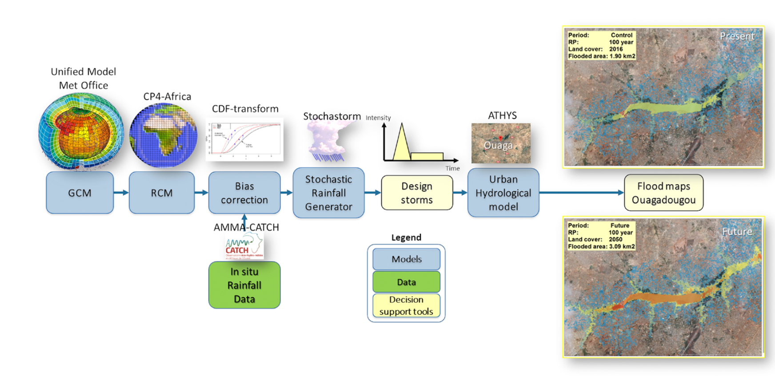
Figure 1: Atmospheric, environmental modeling chain at local city level for floods management decision support system. Capacity for downscaling to local levels and related technology transfer are urgent and important for warnings by NMHSs (BAMS June 2021).

_______________________

